in past decade climate change and difficult access to sustainable energy have motivated governments around the world to set a goal to achieve sustainable green transportation. Electrical Vehicles (EV) is one of the possible way to reduce dependence on petroleum and reduce emission of CO2 and other pollutants and control climate change. Therefore , a number of governments around the world are establishing deployment goals for EVs, automobile industry are researching on this technology shift ,launching variety of new EVs models and trying to reduce the cost of components like batteries to encourage costumers with different budget levels purchase this advanced technology. Electric vehicles.

**EVs Global landscape in 2014**

Governments around the world for achieving their goal which are increasing energy security and reducing the emission of greenhouse gases have set EVs stock targets . Figure …..[1] shows the EVs stock situation in 15 countries which have hold 95% of global EVs stock and electrical vehicle supply equipment stock.

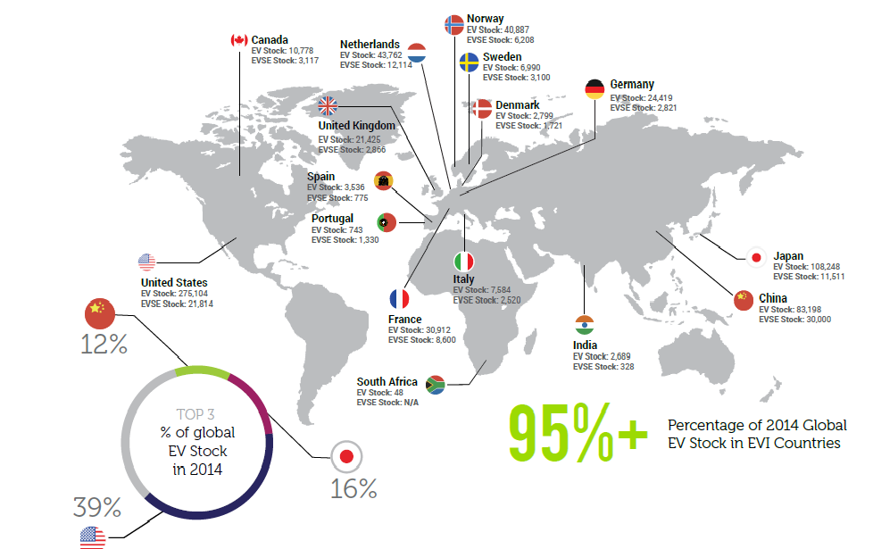

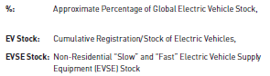

As can be seen from this figure , countries with petroleum access concern have set plan for increasing the use of EVs which result in saving in energy, but petroleum producing and exporting countries are lag terribly behind the rest of the world in deployment of EVs .

**EV Sales Target**

Most countries and policy makers has set a long term EV sale target in the relative near-term 2010-2020 time frame to accelerate sale and use of EV in their own country .

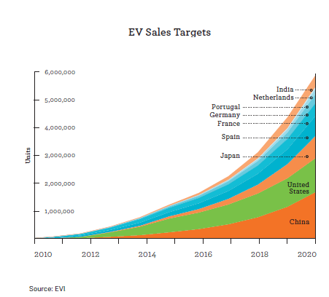

As can be seen from this table , the EV target sale for India and China as two high population countries have a significant difference. India’s EV sale target will reach to 6 million at the end of 2020 while China has planned to reach to 1 million. This variance can be result of the ability of government to access sustainable energy.

**EV Market Share**

Market shares of EV vary significantly across the world. As can be seen from Figure 2, Norway has the highest share of EV sales (BEV and PHEV combined), with about 12.5% of all passenger cars sold in 2014. The Netherlands has the second-highest market share, with about 3.9%**.** The structures of the two markets are entirely different, though: While in Norway nearly all EVs sold are BEVs, in the Netherlands PHEVs clearly account for the majority of the market. Italy has the lowest share of EVs with about 1% .

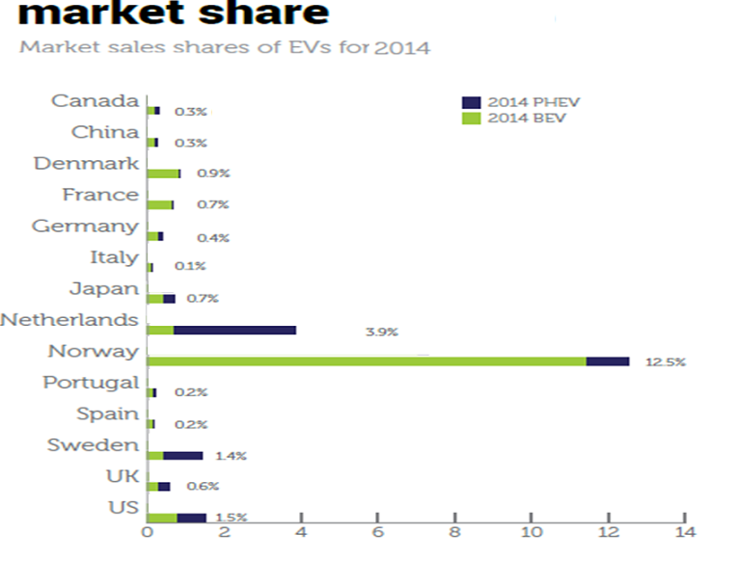

**World EV Models Sales**

EV manufacturer are competing over the market share and each year launch new models to the market to satisfy different target costumers and markets. Figure ….. shows top 10 EV models which had the highest worldwide sale .

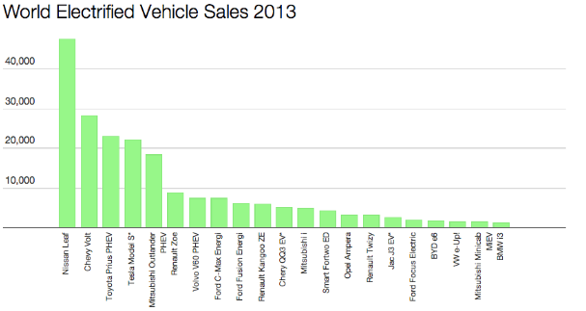

Source: http://evobsession.com

As can be seen from this figure , Nissan Leaf is the Market leader which has almost twice as many sale as the Chevy Volt .

As can be seen from the chart, the large majority of EV sales came from the top 5 models in 2013, representing 67% of all EVs sales. As being in stages of EV revolution the rankings can change very fast as the result of technology improvement, launching new models by current and new companies and many other factors.

**Conclusion:**

The road ahead of Ev market globalization is very long and not easy , EV market share are still around 1% in most major markets, but governments and manufacturer try to deal with all obstacles like high battery cost, EV range limitation and low costumer acceptance and spread the usage of EV between different levels of society .EV market is very naïve and future of the market is belong to companies that can come up with new ideas and better technology to face with challenges and launch better products to market .

1. Global EV Outlook 2015 by Electrical Vehicle Initiative